**Question 1**

Open the **Music Tours - Time Intelligence and Custom Calendars.pbix** file in the folder shown above. This report has the automatic calendar feature disabled.

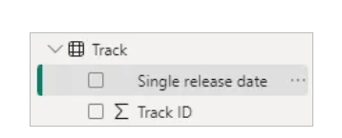

*Date fields in this report don't have an automatic calendar.*

Import the **Track calendar** worksheet from the **Track calendar.xlsx** Excel file. This calendar assumes the financial year ends on the 31st of March.

*The table has several columns related to financial periods.*

Configure this table so that you can use it as a calendar table. Here are some things you might need to do:

* Mark the table as a date table.
* Disable any automatic summing of numeric columns.
* Sort the **Month** and **Weekday** columns by appropriate columns.
* Hide columns from the report view.
* Create a relationship between the **Track** and **Track calendar** tables.

After completing the above tasks your table should resemble the one shown below:

*The finished calendar table.*

Use the **Track calendar** to create the following matrix visual:

*You'll find measures in the****Music Measures****table to help you with this.*

Apply a filter to the matrix visual so that it only shows dates from **1 April 1980**.

*You'll need to add a field to the****Filters on this visual****section of the****Filter****pane to do this.*

Create a measure which shows a year-to-date count of tracks and add this to the matrix.

*Don't forget to reset the count on the end date of the financial year.*

Calculate year-to-date counts for the other two measures in the matrix.

*The final matrix should resemble this.*

Save and close the report.

Question 2

Open the **Music Tours Basic Time Intelligence.xlsx** file in the folder shown above. On **Sheet1** you'll find a pivot table displaying a couple of measures.

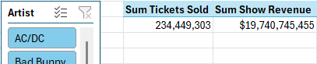

*We'd like to analyse these values by year and month.*

In Power Pivot, choose **Design | Date Table | New** to create a new calendar table. Rename this table as **Show Calendar** and create a relationship to the **Show** table.

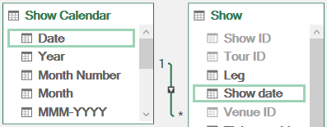

*Connect the****Date****column to the****Show date****column.*

Add the **Year**, **Month** and **Date** fields to the pivot table on **Sheet1**.

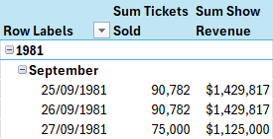

*The table is now divided by dates.*

Create a measure using the **TOTALMTD** function to calculate a monthly running total of tickets sold. Add the measure to the pivot table.

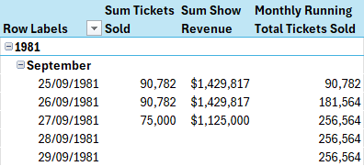

*Annoyingly, the running total makes dates on which no tickets were sold appear in the table.*

To hide the dates on which no tickets were sold, update the measure to include an **IF**function which checks if the sum of tickets sold is blank.

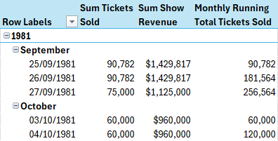

*The table should now hide any dates with no ticket sales.*

Add another measure to calculate a monthly running total of show revenue. Add this measure to the pivot table and make sure that it doesn't cause dates with no ticket sales to appear.

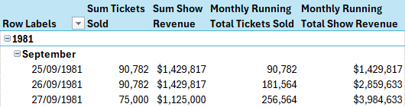

*Apply some formatting to the measure.*

On **Sheet2** you'll find a pivot table showing the total length of tracks released as singles.

An Excel pivot table showing a single DAX measure from a Power Pivot data model

*We'd like to group this measure by date.*

Create a new calendar table called **Track calendar** and connect it to the **Track** table.

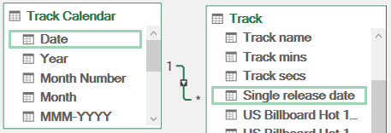

*Connect the****Date****column to the****Single release date****column.*

Add the **Year** and **Month** columns from the **Track Calendar** table to the pivot table on **Sheet2**. Use the **Row Labels** filter to exclude blanks and choose to show subtotals at the top of a group.

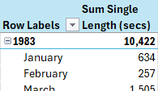

*Each year should show a subtotal for the measure.*

Create a measure which compares the sum of single length with the same period in the previous year. You can use a combination of the **CALCULATE**and **SAMEPERIODLASTYEAR**functions to do this. Add the measure to the pivot table.

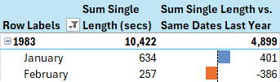

*Add conditional formatting to highlight positive and negative numbers.*

Add a measure which compares the sum of single length with the same value from one month ago. You can use the **CALCULATE**and **DATEADD**functions to do this. Add the measure to the pivot table.

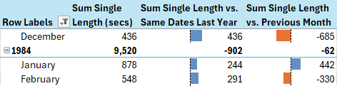

*Conditional formatting might make it easier to read the results.*

When comparing with the previous month, it doesn't make sense to display a value for the year. Try modifying the measure so that it only shows a result when the **Month**column is in scope.

*You can use the****ISINSCOPE****function to check if the****Month****column of the****Track Calendar****table is in scope.*

Check that the subtotals don't appear for years for this measure.

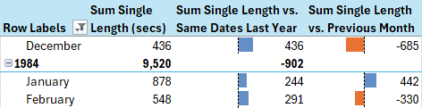

*You should still see subtotals for the first two measures.*

Save and close the file.

**Question 3**

Open the **Music Tours - Basic Time Intelligence.pbix** file in the folder shown above. On **Page 1** you'll find a matrix containing the dates of shows and the tickets sold and revenue generated.

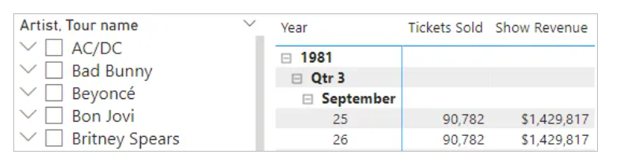

*You can use the slicer to choose different artists and tours.*

Add a measure to create a monthly running total of tickets sold using the **TOTALMTD** function.

*Remember to reference the****Date****column of the automatic calendar table that is related to the****Show date****field, rather than just the****Show date****field itself.*

Add the measure to the matrix.

*Annoyingly, the running total makes dates on which no tickets were sold appear in the matrix.*

To hide the dates on which no tickets were sold, update the measure to include an **IF** function which checks if the sum of tickets sold is blank.

*The matrix should now hide any dates with no ticket sales.*

Add another measure to calculate a monthly running total of show revenue. Add this measure to the matrix and make sure that it doesn't cause dates with no ticket sales to appear.

*You could apply some formatting to the measure.*

On **Page 2** you'll find a matrix showing the total length of tracks released as singles, grouped by year and month.

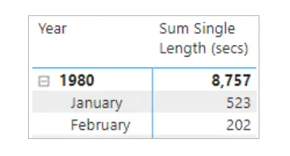

*The matrix has been filtered to show singles released since 1980.*

Create a measure which compares the sum of single length with the same period in the previous year. You can use a combination of the **CALCULATE** and **SAMEPERIODLASTYEAR** functions to do this. Add the measure to the matrix.

*You could add conditional formatting to highlight positive and negative numbers.*

Add a measure which compares the sum of single length with the same value from one month ago. You can use the **CALCULATE** and **DATEADD** functions to do this. Add the measure to the matrix.

*Again, conditional formatting might make it easier to read the results.*

When comparing with the previous month, it doesn't make sense to display a value for the year. Try modifying the measure so that it only shows a result when the **Month** column is in scope.

*You can use the****ISINSCOPE****function to check if the****Month****column of the****Single release date****field is in scope.*

Save and close the report.

Question 2

Open the **Music Tours Basic Time Intelligence.xlsx** file in the folder shown above. On **Sheet1** you'll find a pivot table displaying a couple of measures.



*We'd like to analyse these values by year and month.*

In Power Pivot, choose **Design | Date Table | New** to create a new calendar table. Rename this table as **Show Calendar** and create a relationship to the **Show** table.



*Connect the****Date****column to the****Show date****column.*

Add the **Year**, **Month** and **Date** fields to the pivot table on **Sheet1**.

**Question 4**

Open the **Music Tours Custom Calendars.xlsx** file in the folder shown above.

Import the **Show calendar** worksheet from the Excel file called **Show calendar.xlsx** into the Power Pivot data model.

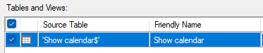

*Import this worksheet.*

Mark the newly imported table as a date table, using the **Date**column as the key.

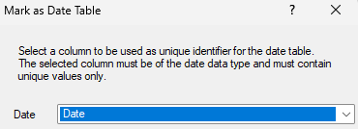

*Use the****Date****column as the unique identifier for the table.*

Set the default summarization of any numeric columns in the table to **Do not summarize**.

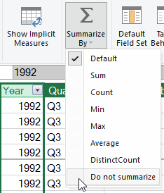

*Power Pivot tries to sum values in numeric columns, like the****Year****column shown here. We don't want this to happen!*

Change the **Sort by Column** setting of the columns shown in the table below:

|  |  |
| --- | --- |
| Column | Column to sort by |
| **Month** | **Month number** |
| **Weekday** | **Weekday number** |

Hide the **Month number** and **Weekday number** fields from client tools so that they won't appear when you're building pivot tables.

Create a hierarchy starting with the **Decade**column. Rename the hierarchy as **Show date hierarchy** and add the columns shown below to it:

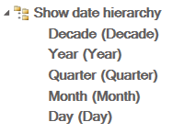

*You can create a hierarchy in the****Diagram view****of Power Pivot.*

Create a relationship between the **Show calendar** and **Show**tables.

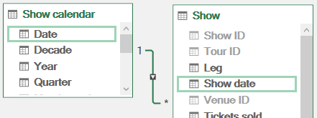

*Create the relationship between the columns highlighted here.*

Use your new calendar table to create the following pivot charts (you'll find some measures in the **Show** table to help you):

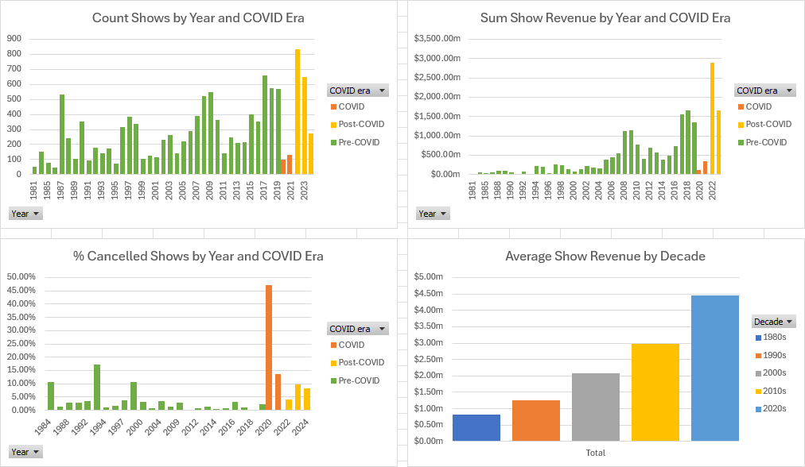

*Change the formatting to suit your preferences.*

Add a slicer which you can use to filter all the charts by the **Weekday** column.

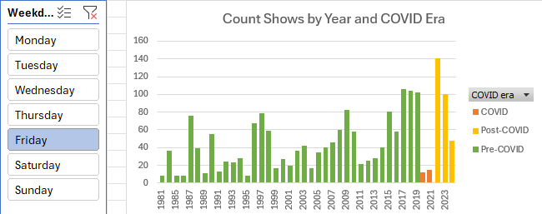

*Connect the slicer to each chart.*

Save and close the file.



*The table is now divided by dates.*

Create a measure using the **TOTALMTD** function to calculate a monthly running total of tickets sold. Add the measure to the pivot table.



*Annoyingly, the running total makes dates on which no tickets were sold appear in the table.*

To hide the dates on which no tickets were sold, update the measure to include an **IF**function which checks if the sum of tickets sold is blank.



*The table should now hide any dates with no ticket sales.*

Add another measure to calculate a monthly running total of show revenue. Add this measure to the pivot table and make sure that it doesn't cause dates with no ticket sales to appear.



*Apply some formatting to the measure.*

On **Sheet2** you'll find a pivot table showing the total length of tracks released as singles.

An Excel pivot table showing a single DAX measure from a Power Pivot data model

*We'd like to group this measure by date.*

Create a new calendar table called **Track calendar** and connect it to the **Track** table.



*Connect the****Date****column to the****Single release date****column.*

Add the **Year** and **Month** columns from the **Track Calendar** table to the pivot table on **Sheet2**. Use the **Row Labels** filter to exclude blanks and choose to show subtotals at the top of a group.



*Each year should show a subtotal for the measure.*

Create a measure which compares the sum of single length with the same period in the previous year. You can use a combination of the **CALCULATE**and **SAMEPERIODLASTYEAR**functions to do this. Add the measure to the pivot table.



*Add conditional formatting to highlight positive and negative numbers.*

Add a measure which compares the sum of single length with the same value from one month ago. You can use the **CALCULATE**and **DATEADD**functions to do this. Add the measure to the pivot table.



*Conditional formatting might make it easier to read the results.*

When comparing with the previous month, it doesn't make sense to display a value for the year. Try modifying the measure so that it only shows a result when the **Month**column is in scope.

*You can use the****ISINSCOPE****function to check if the****Month****column of the****Track Calendar****table is in scope.*

Check that the subtotals don't appear for years for this measure.



*You should still see subtotals for the first two measures.*

Save and close the file.

Question 5

o start, if you haven't already done so run the script in the above folder to generate the **MAM** database (not for commercial use or copying).

Create quarter-to-date and year-to-date total quantity sold measures using the **TOTALQTD** and **TOTALYTD** functions:

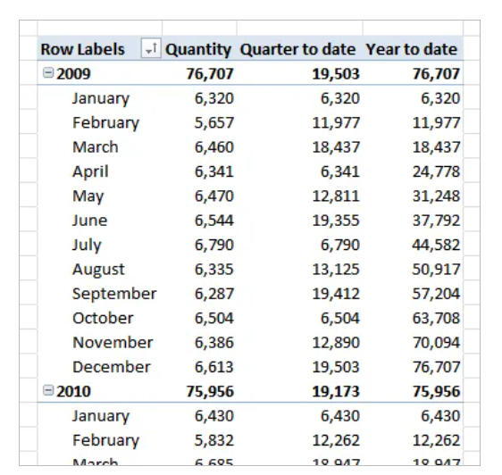

*You'll need to import the****tblPos****,****tblTransaction****and****tblCalendar****tables.*

Save this workbook as **Years and quarters**, then close it down.

Question 6

Good luck!  To start, if you haven't already done so run the script in the above folder to generate the **MAM** database (not for commercial use or copying).

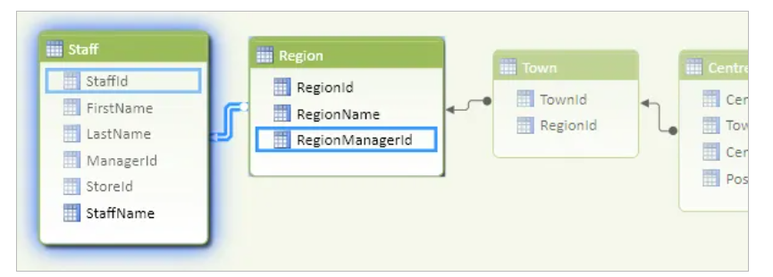

Connect to tables as follows:

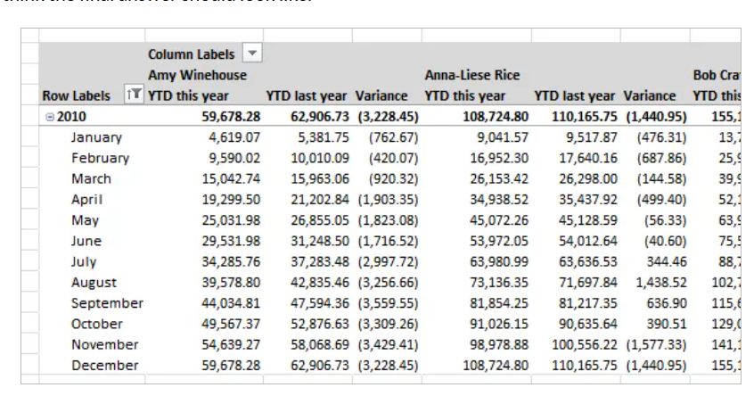

*Most of the tables and relationships are as normal, but each region's****RegionManagerId****must tie in to the value of the****StaffId****field in the****Staff****table.  You'll also need the store, point-of-sale, transaction and calendar tables.*

The company manager wants to be able to compare year-to-date figures for 2010 for the various regional managers against the year-to-date figures for the corresponding previous period.  Your task is to create these figures!

Here's what Wise Owl think the final answer should look like:

*The figures for the first couple of regional managers ...*

*You should find the****DATESYTD****function useful, as shown in the manual.*

Save this workbook as **The full Monty**, and close it down.